**Figure 1 - UML Use Case**

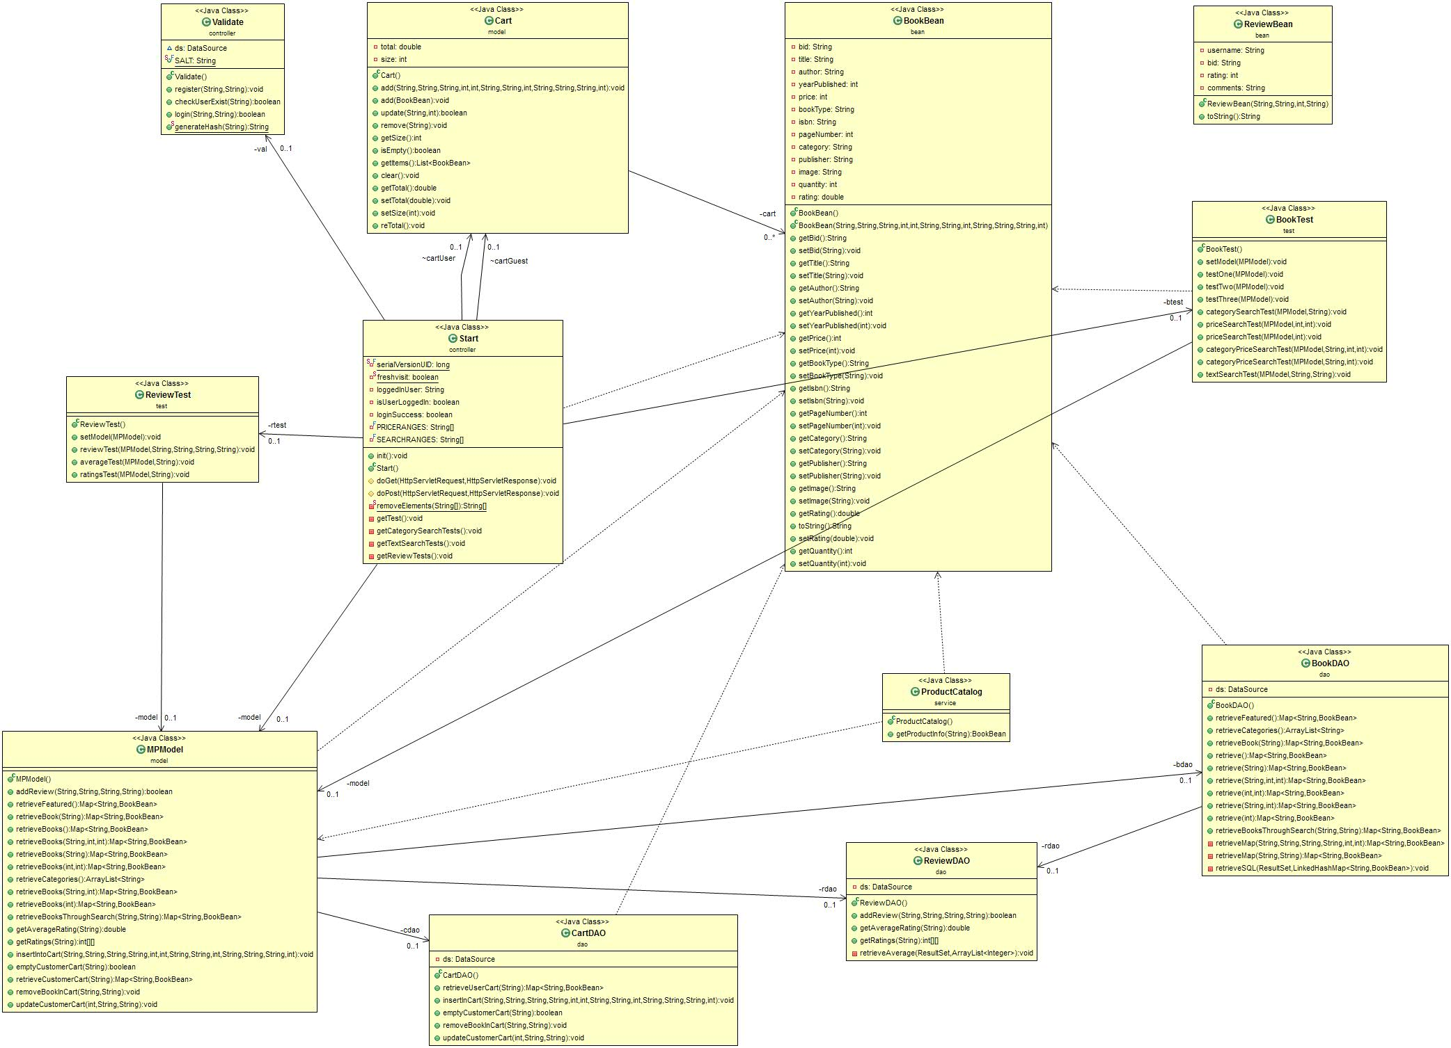

Figure 2 - Class Diagram – Relation between Bookshop and Shopping Cart

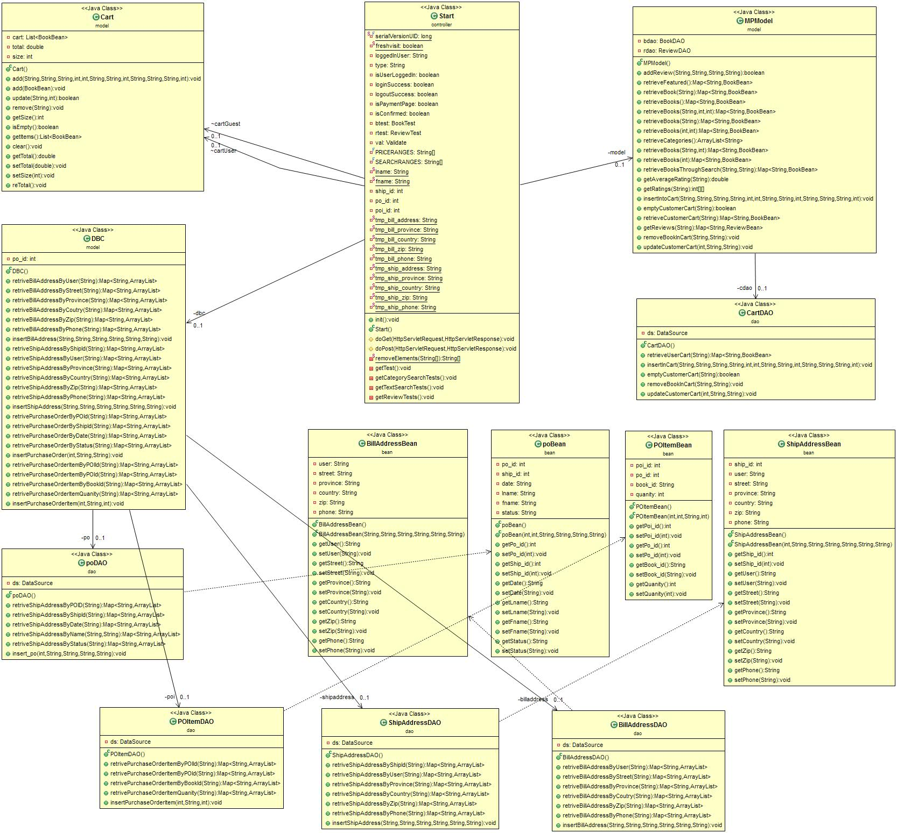

Figure - Class Diagram - Relation between Shopping Cart and Payment Page

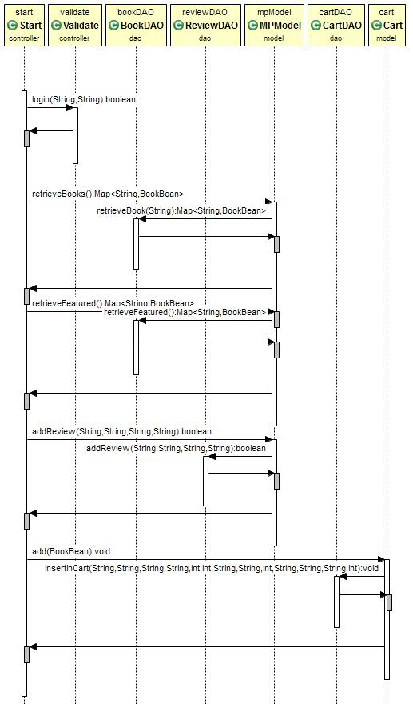

Figure - Sequence Diagram - Bookshop Use Case

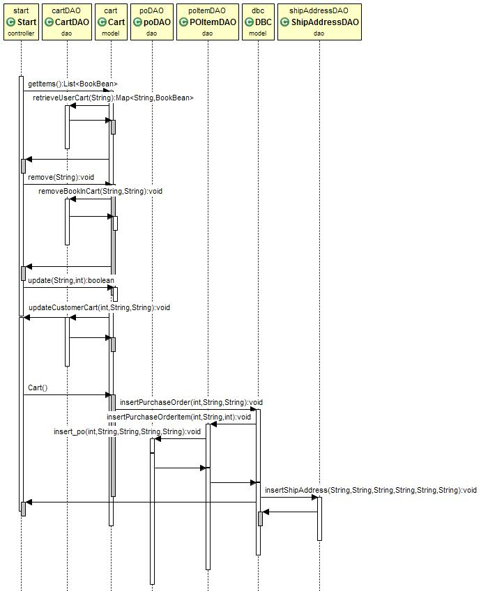

Figure - Sequence Diagram - Shopping Cart Use Case